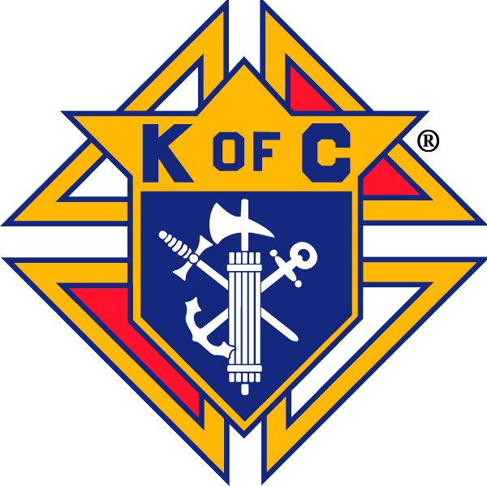
The Knights of Columbus are sponsoring a Day of Reflection by their State Chaplain,

Father William Lesak:

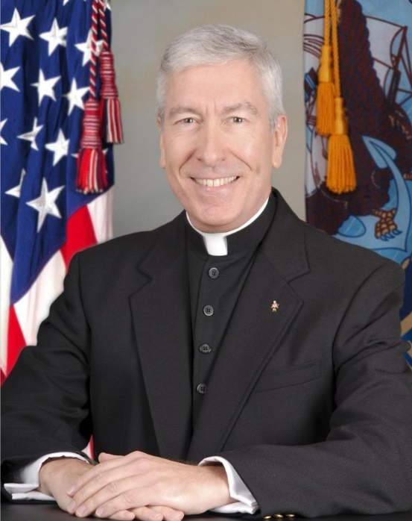
- The Three Forms of Discipleship: Essential Discipleship, Mature Discipleship
& Radical Discipleship
- The Future Church & the Trends Shaping and Reforming the Church in the
21st Century.
  - Why Are Young Catholics Abandoning the Church & Where Are They Going?

Cost is $10 per person to cover costs. Register at: https://www.signupgenius.com/go/60b0949aeac23a13-september
(There is a $1 service fee if you pay online.)

This is a mini-retreat in an interactive, intimate setting. The “Day” will start with Mass and include a light breakfast and box lunch. Open to all adults of the parish, however, registration is limited to the first 50.
Information: Dick Christian, dchristian@imcsuretysolutions.com or 704-577-1911

